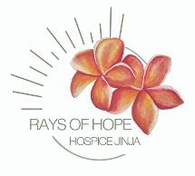ANNUAL REPORT 2023

PRESENTED TO

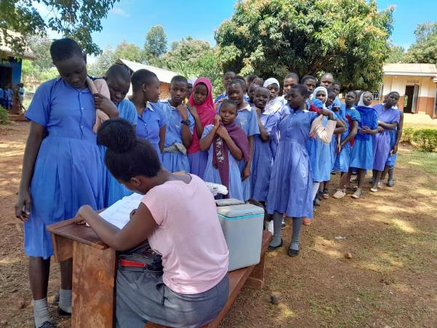FRIENDS OF REACH OUT

*School girls lining up for HPV vaccination against cervical cancer – the most common cancer in Uganda*

Contact Us:

Phone: +256) 771 619 991 / +256) 706 937 307

Email: [raysofhopehospicejinja@gmail.com](mailto:raysofhopehospicejinja@gmail.com) / [hospicejinja@yahoo.co.uk](mailto:hospicejinja@yahoo.co.uk) Website: [www.raysofhopehospicejinja.org](http://www.raysofhopehospicejinja.org/)

Facebook: RHHJ - Rays of Hope Hospice Jinja Twitter: @raysofhopejinja

Instagram: rhhj_raysofhopehospicejinja

**Introduction**

In 2023, Rays of Hope Hospice Jinja (RHHJ) marks eight years of continuous support from FORO for provision of palliative care to patients in need in Busoga region and beyond. We sincerely thank FORO for your invaluable assistance, enabling successful completion of another year of programme growth at RHHJ. FORO commitment has played a crucial role in advancing the mission of palliative care and has greatly impacted the well-being of patients and their families. Thank you FORO for being a dedicated partner in this great journey to enhance and expand our palliative care programmes in Busoga region and beyond.

RHHJ continues to operate in Busoga Region and neighbouring districts, Kayunga and Buikwe – an area of more than 10,000 km2 ( 3861 m2) and more than 4.5 mill. people

In 2023 we have served 1301 patients, 36% men, 64% women and 7% children <18 years. 401 people died, 233 patients improved and were discharged from programme. We had a total of 7926 patient contacts, and 587 consultations of patients who were sick, but not in need of palliative care.

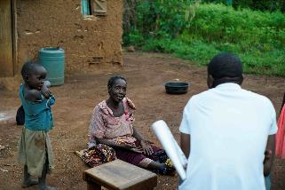**Clinical Care**

FORO and Hospice Jinja Ireland serve as the primary funders for the nursing staff and numerous clinical activities. In 2023, the clinical team, comprised of 8 staff members, successfully executed a range of activities, all important to ensure holistic care for our patients and improve health in the community

**Pain and Symptom Control Management**

The patients enrolled with RHHJ are visited regularly in their homes on pre-scheduled visits. The more stable patients will receive a monthly visit, the more sick patients are visited every 2 weeks. Four teams go out every day, each team seeing an average of 10 patients. Before embarking on the field visits, the day begins with a session of daily morning prayers and review of the patients attended to the previous day.

The clinical palliative care services are designed to alleviate pain and address signs and symptoms associated with life-threatening illnesses or conditions. While the primary focus remains on the patients, the care teams also ensure that the primary caregivers comprehend the necessary information and actions required for the well-being of the patients between visits.

The Buyende Field Office, established in March 2022 has been very successful in reaching patients deep in the remote part of Kamuli and Buyende districts where access to health care is a challenge. Buyende field office is now taking care of 23% of the patients enrolled. Due to the deep poverty there, these patients are often quite challenging and need extensive support. In order to reach other distant corners of the Region we are still having biweekly outreaches to two areas, where the team will stay for two nights to better reach the patients. It is planned that RHHJ shall establish a field office in Namyingo District in 2024 covering the districts in Mayuge, Namayingo and Bugiri.

**Treatment Support**

Rays of Hope Hospice Jinja consistently aids financially challenged cancer patients, providing essential treatments like chemotherapy, radiotherapy, surgery, and diagnostic investigations. Collaboration with key institutions, including Uganda Cancer Institute, Mulago National Referral Hospital, Baylor Children Oncology Services, Afri Egypt Hospital, and Kyabirwa Surgical Centre, eases access to investigations and treatment, alleviating suffering.

***Rebecca gets back to work after treatment of cervical cancer***

*Rebecca a 47 years old female a mother of 3 was enrolled with Rays of Hope in April 2021, referred by a fellow patient. She presented with excessive abnormal bleeding and a fowl smelling discharge per vagina since July 2020. Rebecca had sought treatment from private clinics and herbalists without improvement. In April 2021, she was diagnosed with cancer of the cervix and referred to Uganda Cancer Institute, but she did not want to go because of lack of money and fear to die from side effects of treatment.*

*Following enrollment, intensive counselling was done to her until she finally reconsidered treatment at UCI. RHHJ paid for her diagnostic tests and treatment of chemotherapy and radiation. Rebecca’ treatment resulted in complete resolution of her symptoms, and she is now back working at the landing site in Mayuge District selling silver fish to support herself and the children. She is very grateful for the support and the ray of hope shone by RHHJ staff. 😊 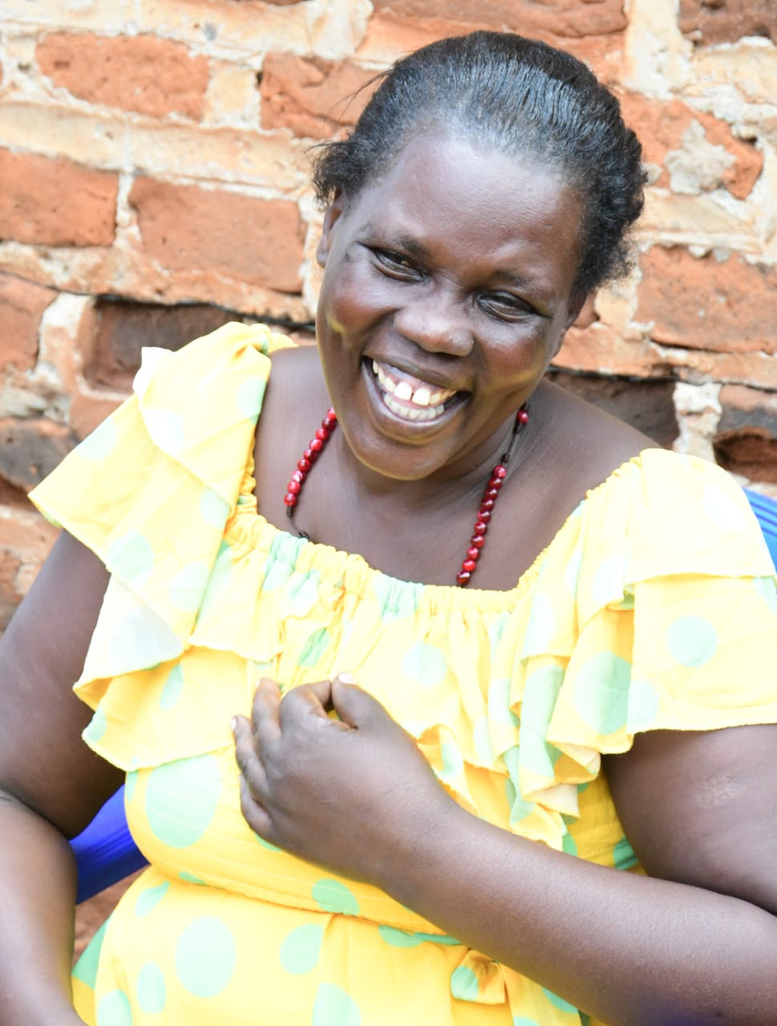*

In 2023, 231 patients received treatment support—193 newly supported, and 38 continuing from 2022. RHHJ covers investigation and treatment costs as well as support for upkeep and travel for the most poor. Uganda Cancer Institute (UCI) patients are met and helped throughout their stay by a patient navigator, provided by Rays of Hope Hospice Jinja, so that they are not lost at the maze of diagnostic and treatment appointments.

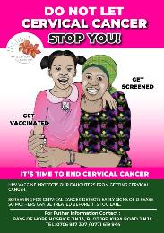**Cervical and Breast Cancer Prevention**

In 2023 RHHJ has fully embraced the WHO strategy for accelerated elimination of cervical cancer as we are now working with all three strategies of of cervical cancer elimination - vaccination, screening and treatment.

The targets set by WHO are:

90% of girls fully vaccinated with HPV vaccine by age 15 years

70% women screened by 35 years of age and again by 45years of age

90% of women with pre-cancer treated , and 90% of women with invasive cancer managed

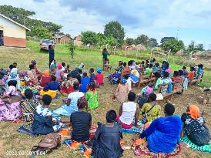During 2023 2,741 women were **screened for cervical cancer**. The screenings were done from the four government clinics established in 2022 as well as from 42 community outreaches throughout Busoga Region and neighbouring districts. Screening is offered to all sexually active women and those living with HIV/AIDS. Women with precancerous lesions received treatment through thermo-coagulation on site. Individuals identified with suspicious cervical lesions and breast lumps were referred to diagnostic centers, ensuring close follow-up and providing financial support when necessary. It is our experience that the screening offerd MUST be combined with support for further investigations and treatment as needed.

In order to maintain high quality screenings refresher training sessions for screeners who had been trained but not confident in screening were conducted twice, benefiting a total of 29 participants. Furthermore, ten new screeners received training to enhance accessibility to screening services for health workers in both Buikwe District and at RHHJ.

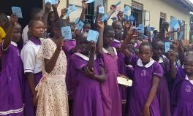In Buikwe district, a total of 115 teachers from 40 schools were sensitized during **HPV vaccination** campaigns. The district had previously very little uptake of the vaccination, but inspired by the training given to all levels involved the interest has increased very markedly. Facilitated by RHHJ, 2,389 girls from 22 primary schools received vaccinations, contributing to the comprehensive health initiatives in the region. This was a pilot programme to improved uptake of HPV vaccines which is low from the majority of health centers. The pilot was very successful and it will be expanded to include more districts in 2023.

**Training of Health Workers, Sensitizations, Stake Holders’ meetings and Conferences**

The training of health workers at Rays of Hope Hospice Jinja (RHHJ) has been comprehensive and impactful. Eleven external Continuing Medical Education (CME) sessions were conducted at various health centers in the region, engaging 312 participants, in order to provide health workers with knowledge on various cancers.

Internally, 17 CMEs were offered to RHHJ staff, contributing to their continuous professional development.

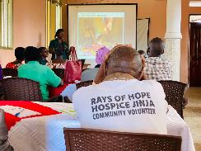A notable achievement was the delivery of a 2-day refresher training course for health workers in Luuka and Jinja. This initiative trained 44 health workers from 24 health facilities, resulting in a significant increase in patient referrals for palliative care.

Quarterly refresher training sessions were organized for the 73 community volunteers, ensuring their continuous and accurate identification and follow-up of patients in the community. These volunteers received support in the form of a monthly lunch incentive, equipment, and a Christmas food package.

Extensive community engagement was achieved through sensitization meetings in Jinja and Bugiri districts, attracting 337 participants. Stakeholders' meetings in the districts of Buikwe and Mayuge were attended by 61 participants, fostering collaboration and shared understanding.

Community awareness on cancer and palliative care was elevated through diverse programs, including radio talk shows, radio adverts, TV shows, community megaphones, brochures, annual reports, and distribution of fliers during stakeholders' meetings and screening camps throughout the year.

**Capacity Building of RHHJ Staff**

Upgrading and improving the skills of our RHHJ employees remains a key priority for RHHJ, and several members are currently engaged in continuous education in various professional fields:

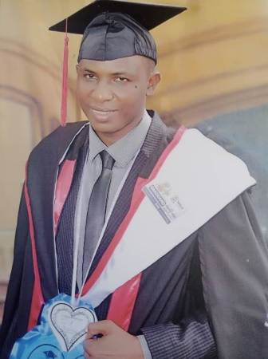Ongoing: One is pursuing Masters in Public Health (Clarke International University), and one is pursuing Bachelor of Science in Palliative Care (IHPCA).

In 2023 three staff members have completed their training and are now awaiting their graduation, one: Postgraduate diploma in financial management (UMI), one has completed Bachelor of Science in Palliative Care (IHPCA), and the third has completed Higher Diploma in Palliative Care (IHPCA).

One staff member, our M&E officer successfully graduated in 2023, earning a Bachelor of Information Technology from Ndejje University—an achievement celebrated by the organization.

**Research and Conferences**

RHHJ staff actively participated in two conferences hosted by PCAU (Palliative Care Association of Uganda) and KEHPCA (Kenya Hospice and Palliative Care Association), presenting a total of five papers at each conference. This not only showcased RHHJ's commitment to ongoing learning and knowledge sharing but also contributed valuable insights to the broader health/medical community.

Data has been collected for a Financial Distress study, a collaborative effort with a Mt. Sinai medical student. Our anticipation is high as we aim to gain better insights into how serious diseases impact the financial well-being of our patients and their families.

Building on the success of the 'Effects of Group Advocacy Training Programme on Cervical Cancer Screening Among Social Network Members' plot study, we have initiated a continuing five-year study on the 'Game Changers in Prevention of Cervical Cancer' started in August 2023. RHHJ is grateful for the ongoing collaboration with Makerere School of Public Health, Rand Corporation, USA, and the African Palliative Care Association in this important research.

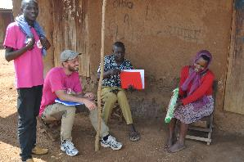We are pleased to announce the publication of a retrospective study conducted in collaboration with the University of Aarhus, Denmark, addressing the fight against cervical cancer in Uganda. This study has been published in the journal called Public Health <file:///C:/Users/margr/OneDrive/DOCUME~1/RAYSOF~1/RESEAR~1/AARHUS~1/CERVIC~1/PUBLIS~1/FIGHTI~1.PDF>

Furthermore, data collection for a KAP (Knowledge, Attitudes, and Practices) study on cervical cancer, HPV vaccination, and breast cancer was conducted in November and December, involving 580 interviews. This study is the first of its kind in rural Uganda, and we eagerly await the results, which are expected to significantly contribute to the enhancement of our breast and cervical cancer prevention and control programme.

Psychosocial programme

Every day spent in the field providing home-based patient care reinforces our awareness of how illness profoundly incapacitates individuals and their families in so many ways—psychological, social, economic, and medical. These aspects intricately influence one another, creating a challenging landscape for those affected. Motivated by this understanding, we strive to alleviate some of the burdens posed by these challenges for patients and their families.

In 2023 FORO has assisted with part of the psycho-social support team, which comprises of 2 social workers and 2 assistants.

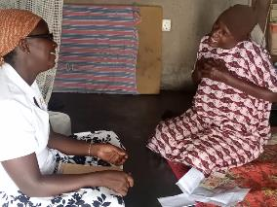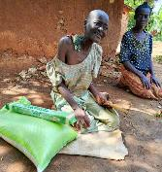Acknowledging the importance of food as a crucial aspect of patient care, RHHJ continues to provide food for our most needy patients. On an average per month 150 patients receive a food basket of 3 kg rice, 2 kg beans, 1 kg sugar and a big bar of soap. 100 patients who have difficulty eating will get 2 kg of nutritious porridge to support their diet and help with treatment adherence. 400 of the poorest patients got a Christmas package of rice, beans, sugar, and soap. In addition an average of 100 patients per month receive comfort fund, a small financial support of UGX 10,000 ($2.75) to help with small essential expenses.

**Counselling, Bereavement and Memorial Services**

**Counseling** plays a crucial role in helping patients cope with psychological, mental, and social challenges during illness. Our RHHJ team ensures that all patients receive counseling to address their worries and distresses. Through these sessions, patients can share their struggles in dealing with the hardships that accompany their illnesses.

In addition, **bereavement visits** are made to families who have lost their loved ones. During these visits, **the team** offers sympathy, counseling, and a condolence fee of 10,000/= per family. This gesture reflects a sense of togetherness and signifies a new beginning amidst the challenges that come with loss of a loved one..

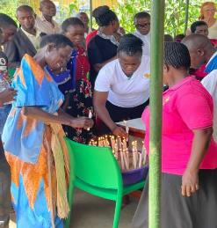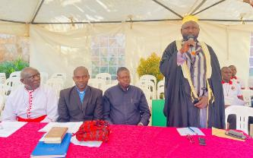This year **memorial services**, always held in November, were conducted both at the main office in Jinja and at the Buyende Field Ofiice. These services provides moments of prayer and reflection for the former caretakers of departed patients. This year the events were attended by over 135 participants and religious leaders from diverse denominations, including Anglicans, Catholics, and Muslims, were together leading the congregation in prayers

.

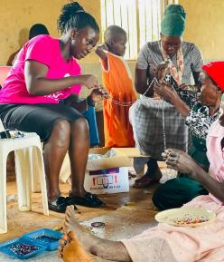**Day Care Activities**

Rays of Hope Hospice Jinja (RHHJ) organized twenty-four (24) day care activities throughout the year, with 644 participants from various routes. The Daycares are for patients and their carers, where they can spend a day together, get a good meal and meet and support Social workers facilitated discussions, focusing on patients' feedback. Patients reported how these sessions helped them recover from the grieving processes following their diagnoses. Despite facing predictions of imminent death, RHHJ provided hope, making them feel loved and encouraging them to live on.

The day care activities included engaging hand and craftwork, such as mat and basket weaving, paper bag making, and beadwork. These sessions proved beneficial, addressing various dimensions of patients' illnesses and care, reducing physical suffering, depression, and complicated grief. Patients also shared their anticipatory grief experiences, fostering mutual understanding among participants..

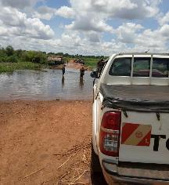**Transport**

There is no homebased care without transport, and we are very grateful to FORO for providing fuel, drivers and insurance for our four vehicles. Every day they take a team of clinicians and social workers out into the field for home visits or one of the more special activities like screening, training etc. Each car drives on average 3000 km/1,875 miles per month. The roads are rough and often close to impassable, but the teams will get where they need to go – the patents cannot wait for us 😊

**School Fees Support Program Highlights ( full report will follow for this special programme)**

The school support program provides crucial assistance to families unable to afford school fees, scholastic materials, meals, and uniforms. This initiative aims to ensure children's education, paving the way for a brighter future despite parental disease or death. .

In 2023 the total beneficiaries were 140. Primary section 92, Secondary 36 and vocational 12.

During the year the social workers visit with the children at least once per term s to address challenges and support students for better performance. Here the students will also receive guidance on various life matters, particularly those approaching puberty, helping them navigate challenges such as early relationships and avoiding temptations. 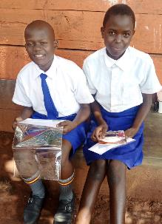

In 2023 18 candidates were registered for exams - 4 for UCE (Uganda Certificate of Education), and 14 for PLE (Primary Leaving Examination). All candidates received success cards to encourage them during their final examinations.

Older female students received reusable pads to support them during menstruation, promoting school attendance and avoiding potential risks.

20 students, facing instability or security concerns at home, were enrolled in the boarding section during term 3 to enhance concentration on studies.

Some students received bedding (mattresses, blankets, and bedsheets) to ensure a more comfortable night's sleep.

During the year 14 new students were enrolled at different levels (Primary, Secondary, Vocational Studies). Four primary pupils dropped out, and efforts were made to retain them without success.

Four students living with HIV/AIDS attended a three-day regional symposium organized by St. Francis Health Care Services in Njeru. The event aimed to empower youth in HIV decision-making towards achieving the UN Goal of ending HIV/AIDS by 2030.

Financial Report

New Strategic Plan 2024-2028

As Rays of Hope Hospice Jinja (RHHJ) concludes its inaugural five-year plan, we celebrate significant achievements. The holistic palliative care program has doubled its reach, providing critical treatment support to those in need. Preventive initiatives, screening over 7500 women for cervical and breast cancer, have contributed to early-stage treatment for around 500 individuals. Our psychosocial support has expanded, aiding patients and their children in navigating the challenges of serious illness.

Looking ahead to the next five years, the new strategic plan for 2024-2028 aligns with the UN Sustainable Development Goals, aiming for improved access to healthcare that is affordable and available when and where needed. Our daily work confronts us with the harsh reality of the lack of access to affordable quality care for the impoverished rural people in Busoga Region, resulting in preventable and treatable diseases causing much unnecessary suffering.

Rays of Hope Hospice Jinja new vision is centered on cancer prevention, early detection, and palliative care for all in Busoga Region and beyond. The mission is to advance cancer prevention, early detection, and the improvement of the quality of life for patients and families affected by severe illness. In the 2024-2028 Strategic Plan, improving access to palliative care takes center stage, with a focus on providing services where patients can easily reach or be reached. This includes establishing field offices and capacity-building initiatives among health workers and communities, emphasizing education in cancer for improved diagnosis and referral before cancers advance. Cancer prevention will be enhanced through HPV vaccination and combined cervical cancer and breast screening, ensuring treatment for positive results.

Given the limited knowledge about cancer in Busoga Region, awareness creation, community education, and advocacy will receive high priority. RHHJ, having established a robust monitoring and evaluation system in the past strategic plan, will further strengthen it, with a keen focus on accountability and learning. Research will play a central role in gaining a better understanding of key questions and issues related to cancer prevention and palliative care, positioning RHHJ as a center of excellence for rural palliative care.

Recognizing that only 11% of Uganda's population has access to palliative care, and even less so for other rural populations in Africa, RHHJ is committed to refining a low-cost care model that can be replicated in other rural areas. This is a journey we cannot walk alone. We invite our faithful partners to continue walking with us and also welcome new partners as we explore sustainable ways forward.

The journey ahead is long but it holds exciting prospects. We shall keep striving forwards as we strive to make a lasting impact on the lives of those we serve.

Thank you FORO for walking with us this far – we pray that we shall continue to move forward together.

